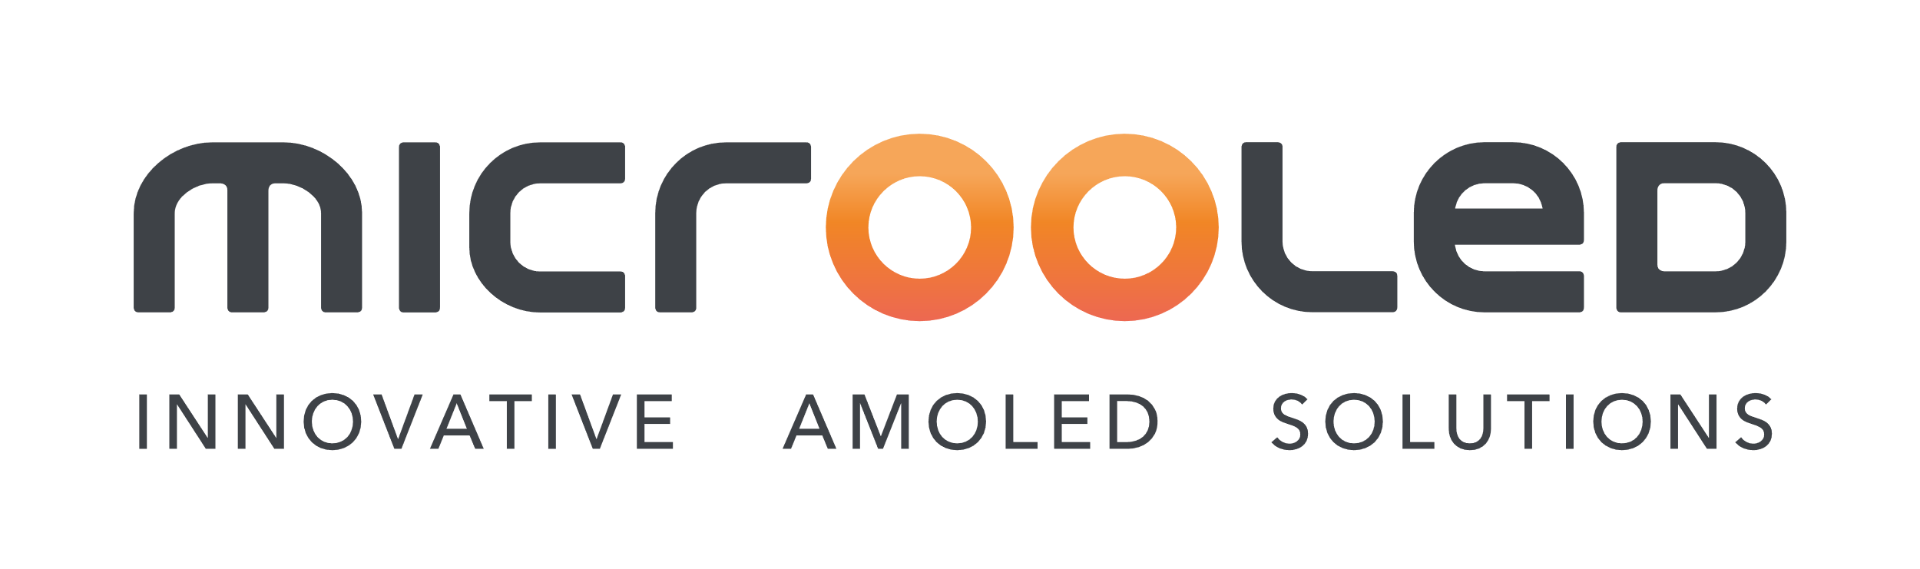

**L’ENTREPRISE :**

**MICROOLED**, a human sized company develops, manufactures, and sells OLED microdisplays with very high resolution, outstanding image quality, and high power efficiency for applications like electronic viewfinders, head mounted displays, wearable Augmented Reality, Virtual Reality, etc. The company has its offices and a dedicated microdisplay manufacturing line inside the MINATEC innovation campus in Grenoble/ France.

**CONTACT :**

**You are interested in new technologies and you are looking for an internship in a dynamic and innovative environment,**

**Do not hesitate, send us your application!**

**Emmanuelle Arbet - DRH**

[**emmanuelle.arbet@microoled.net**](mailto:emmanuelle.arbet@microoled.net)

[**www.microoled.net**](http://www.microoled.net)

[**www.activelook.net**](http://www.activelook.net)

[**www.engoeyewear.com**](http://www.engoeyewear.com)

**Final year internship offer : Light Extraction enhancement in OLED microdisplays**

**Duration : 6 months**

**DATE : from February 2024**

**Context & Objective:** Our microdisplays are based on Organic Light Emitting Diodes (OLED) on CMOS. In order to enhance luminous efficiency and brightness of the OLED stack, the goal is to study the improvement that can be obtained by integrating optical arrays like e.g., micro lenses.

**Mission:**

**As member of the R&D team, you will**

* establish a simulation model for the emission of the system OLED plus optical array based on Setos for the OLED and Zemax for the optical simulation
* validate the model using existing samples with microlens arrays
* study different designs in terms of lens shape, optical parameters, pixel layout etc.

**Profil:**

Final-year student in optics or physics engineering

Good knowledge in non-imaging optics, optics of thin films, optical measurement, programming.

Knowledge of Zemax as well as of light extraction techniques in OLEDs or LEDs would be a plus.

Self-motivation and enthusiasm

Language : French/english